

# Experiment 1

**Student Name: Archit Kaushal UID: 23BCS10313**

**Branch: B.E.CSE Section/Group: 23BCS-KRG-2B**

**Semester: 5th Date of Performance:21-07-25**

**Subject Name: ADBMS Subject Code:23CSP-333**

# Aim:

# Create a database schema to model the relationship between authors and books using SQL. Begin by designing two tables: one named `Authors` to store details such as the author's ID, name, and country; and another named `Books` to store details such as the book's ID, title, and a foreign key that references the corresponding author's ID. Populate each table with at least three sample records. Then, write an SQL query using an `INNER JOIN` to retrieve a list that links each book with its respective author. The final output should display the book title, the author’s name, and the author’s country. This exercise will demonstrate your ability to design relational tables, establish foreign key relationships, and perform join operations to combine related data across multiple tables.

# You Design and implement a relational database schema to represent academic departments and the courses they offer. Start by creating two normalized tables: one for `Departments`, storing each department's ID and name, and another for `Courses`, containing course details along with a foreign key referencing the corresponding department. Populate the `Departments` table with five entries and the `Courses` table with at least ten courses distributed across those departments. Next, use a subquery to count how many courses are associated with each department, and retrieve only those departments that offer more than two courses. Finally, demonstrate the application of access control by granting `SELECT`-only permission on the `Courses` table to a specific user. This exercise evaluates your ability to normalize data, use subqueries effectively, filter based on aggregate conditions, and implement basic SQL access control.

# Objective:

# To understand how to use JOINS in SQL.

# To understand the basic SQL Queries.

# To generate hierarchical reports from self-referencing tables.

# DBMS script and output:

# C:\Users\Archit\AppData\Local\Microsoft\Windows\INetCache\Content.Word\Screenshot 2025-07-29 220118.png

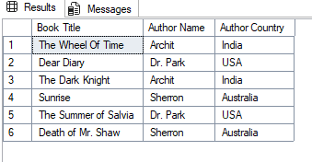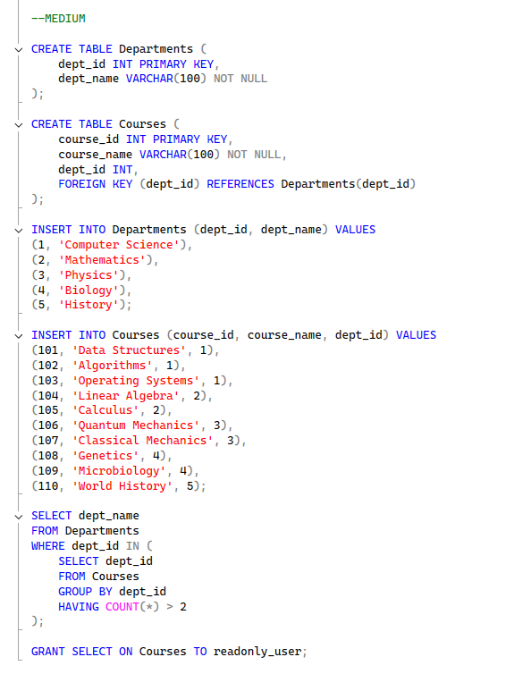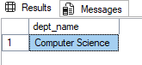

1. **Learning outcomes:**

* You will be able to write basic SQL queries.
* You will learn to perform JOINS in SQL.
* You will understand how to implement foreign keys.